Assignment No 8

Formatting Query Output.

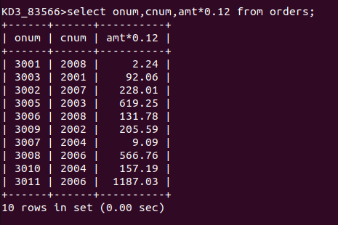
1) Assume each salesperson has 12% commission. Write a query on the orders table that will produce the order numer, the salesperson number, and the amount of the salesperson’s commission for that order.

Q2) Write a query on the customers table that will find the highest rating in each city. Put the output in this form.

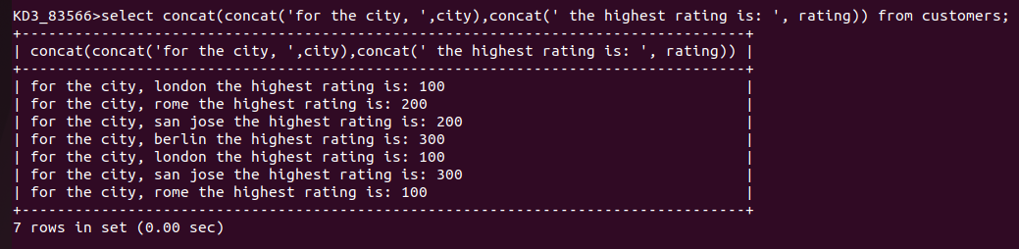
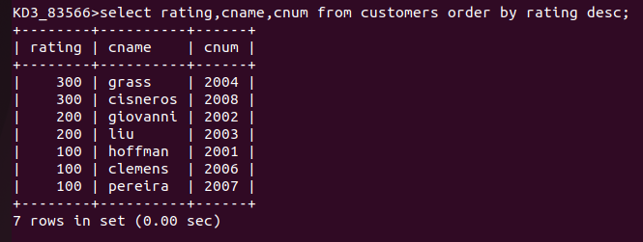
Q3) Write a query that lists customers in the descending order of rating. Output the rating field first, followed by the customer’s name and number.

Q4) Write a query that totals the orders for each day and places the results in descinding order.

